



LAB MANUAL
Static Methods with Class and Object

Disclaimer: The content is curated from online/offline resources and used for educational purpose only
Static Methods with Class and Object
Objectives:
- To demonstrate the use of static methods within a Python class.
- To simulate an e-commerce shopping cart system, where static methods are used to perform tasks like formatting prices and calculating taxes that are not dependent on specific instances of the class.
- To show how static methods can be used for utility operations that are related to the class but do not interact with instance variables.
Problem Statement:
In an e-commerce system, you need to manage a shopping cart where customers can add items, calculate totals (including tax), apply discounts, and format prices for display. The system will also calculate taxes on specific amounts independently of the shopping cart. Static methods are ideal for tasks that do not require interaction with instance variables but are related to the class logic.
Procedure:
Task 1: Define the Shopping Cart Class and add items
Task 2: Calculate Total Price Including Tax
Task 3: Apply Discount to the Total Price
Task 4: Format Price for Display and Calculate Tax Independently

Code:
Task 1: Define the Shopping Cart Class and add items
we define a ShoppingCart class with a class attribute tax_rate, which represents the sales tax percentage. This attribute is shared among all instances of the class, making it easy to maintain and modify tax rates across the application.
- The __init__ method is the constructor that initializes an instance of the ShoppingCart class.
- It creates an empty list called items, which will store each item added to the shopping cart as a dictionary (containing item name and price).
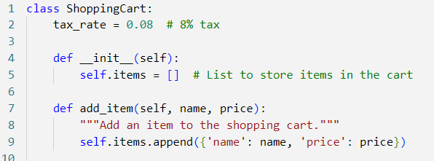

Task 2: Calculate Total Price Including Tax
- The calculate_total method calculates the total price of items in the cart by summing their prices.
- It then calculates the total amount including tax by multiplying the total by the tax_rate and adding it to the original total.
- The method returns the final total amount including tax.
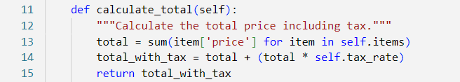

Task 3: Apply Discount to the Total Price
The apply_discount method takes a discount percentage as a parameter.
It first calls calculate_total() to get the total price, then calculates the discount amount based on the total.
The final amount after the discount is applied is returned.
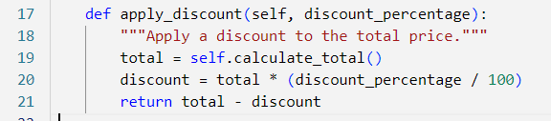

Task 4: Format Price for Display and Calculate Tax Independently
The format_price method is a static method that takes an amount and formats it to a string representing a price in US dollars (e.g., $100.00).
This method does not depend on instance data and can be called using the class name directly.
Like format_price, the calculate_tax method is a static method that takes an amount and calculates the tax by multiplying it by the class attribute tax_rate.
This method can be called without creating an instance of ShoppingCart, making it useful for any part of the application that needs to calculate tax.
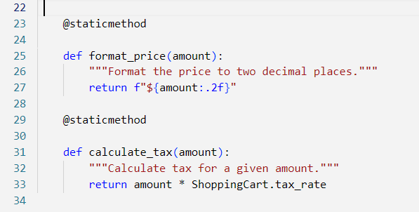

Example usage:
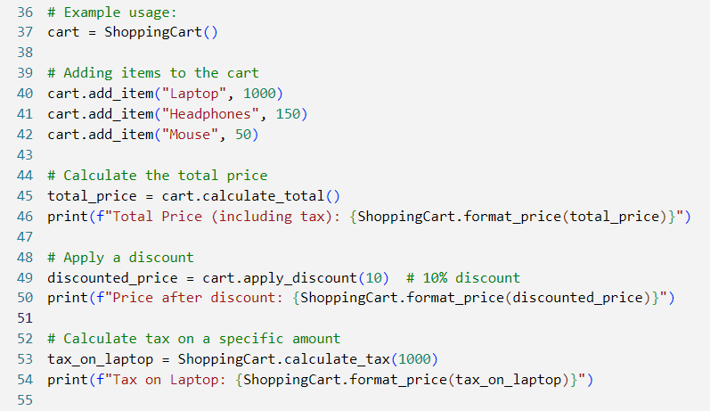

Output:
